Environment
Method
Machine
People

Problem

Measurement
Material

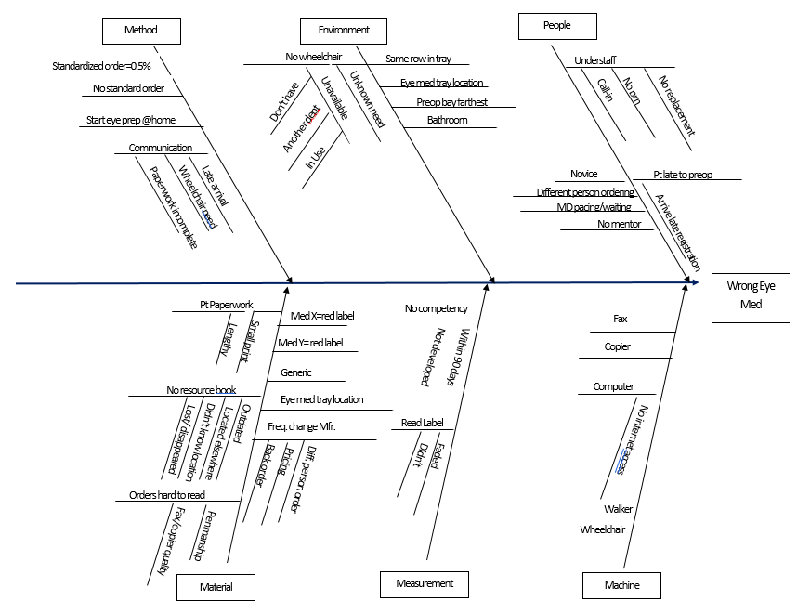

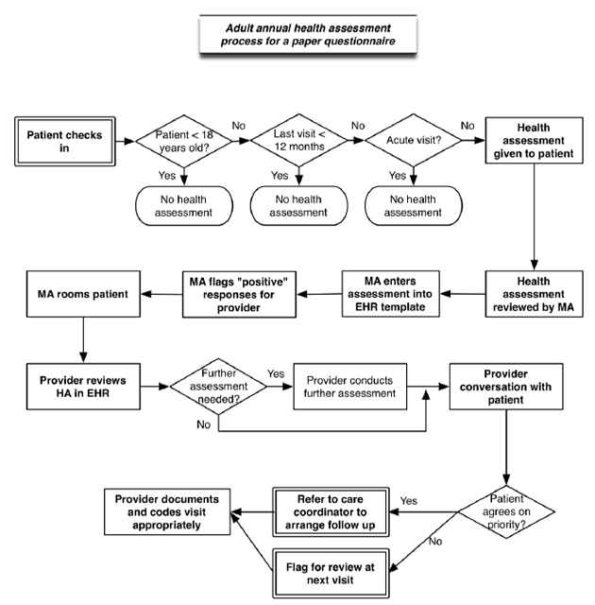

https://www.ahrq.gov/sites/default/files/wysiwyg/professionals/prevention-chronic-care/improve/system/health-assessments/exprocessmap.gif

